*Florida International University*

*School of Computing and Information Sciences*

Software Engineering Focus

Feature Document

User Story #**166**

**Team Member:**

Jose Morgan

**Product Owner(s)**:

Francisco Ortega

**Mentor(s)**:

Francisco Ortega

**Instructor**: Masoud Sadjadi

**User Story** Implement ….

* As a user I would like to be able to collaborate with other users when using the interactive paint app regardless of what input device the other users are using.

Acceptance Criteria

* No input device’s actions should override any other input device
* All devices should be placed in their own thread

**Use Case Diagram**

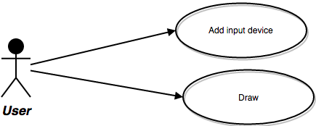

**Sequence Diagram**

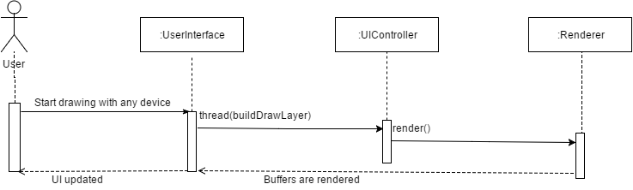

**Class Diagram**

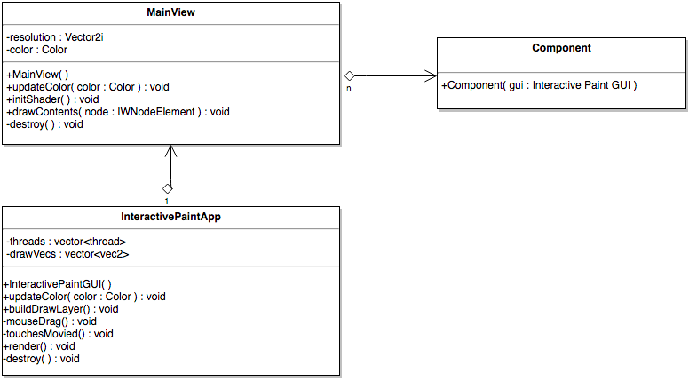

**Integration Test**

Multiple users used the app to draw for a few minutes using a multi touch display. No significant bugs came up while they were drawing.